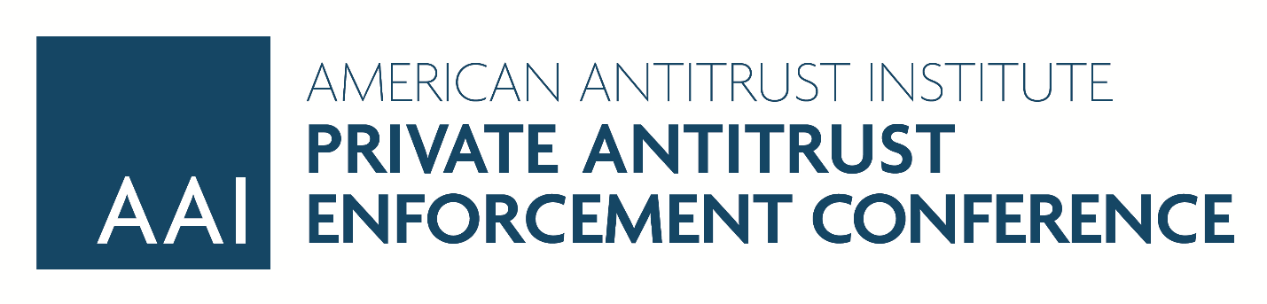
Supporting Materials

Young Lawyers Breakfast
- Robert Lande, Private Enforcement of Antirust Law in the United States: A Handbook, Introductory Chapter, Edward Elgar (2012).
- Stephanie A. Scharf & Roberta D. Liebenberg, First Chairs at Trial - More Women Need Seats at the Table: A Research Report on the Participation of Women Lawyers as Lead Counsel and Trial Counsel in Litigation, American Bar Association (2015).
- Kennedy, A Cultural Pluralist Case for Affirmative Action in Legal Academia, 1990 Duke L.J. 705.
- Kevin Woodson, Race and Rapport: Homophily and Racial Disadvantage in Large Law Firms, 83 Fordham L. Rev. 2557 (2015).

Litigating Antitrust Cases after Ohio v. Amex: Two-Sided Platforms and Beyond
- Jeffrey Lynch Harrison, Ohio v. American Express: Misunderstanding Two-Sided Platforms, the Credit Card 'Market,' and the Need for Procompetitive Justifications (2018)
- Michael Katz & Jonathan Sallet, Multisided Platforms and Antitrust Enforcement, Yale L. J. 2018 (forthcoming)
- Patrick Ward, Testing for Multisided Platform Effects in Antitrust Market Definition, 84 University of Chicago Law Review 2059 (2017)

What if Illinois Brick and Hanover Shoe were Overturned? Examining the Hypothetical Fallout and Exploring Alternative Solutions to Promote Deterrence and Compensation
- Matthew M. Duffy, Chipping Away at the Illinois Brick Wall: Expanding Exceptions to the Indirect Purchaser Rule, 87 Notre Dame L. Rev. 1709 (2013)
- Christopher T. Casamassima & Tammy A. Tsoumas, The Illinois Brick Wall: Standing Tall, 20 NO. 1 Competition: J. Anti. & Unfair Comp. L. Sec. St. B. Cal. 67 (2011)
- Barak D. Richman & Christopher R. Murray, Richman and Murray, Rebuilding Illinois Brick: A Functionalist Approach to the Indirect Purchaser Rule, 81 S. Cal. L. Rev. 69 (2007)
- Jay L. Himes, Two Enforcers Separated by a Common Mission: Public and Private Attorneys General, The Federal Bar Council Class Actions – The Latest (March 4, 2008)

Mock Class Certification/Daubert Hearing in an Antitrust Class Action: A Demonstration and Discussion of Best Practices for Direct & Cross of Experts
- Linda S. Mullenix, Putting Proponents to Their Proof: Evidentiary Rules at a Class Certification, 82 Geo. Wash. L. Rev. 606 (2014)
- Joshua P. Davis & Eric L. Cramer, Antitrust, Class Certification, and the Politics of Procedure, 17 Geo. Mason L. Rev. 969, 1033 (2010)
- Heather P. Scribner, Rigorous Analysis of the Class Certification Expert: The Roles of Daubert and the Defendant's Proof, 28 Rev. Litig. 71, 106 (2008)

Private Antitrust Enforcement and the New Supreme Court
- Robert H. Lande & Joshua P. Davis, Restoring the Legitimacy of Private Antitrust Enforcement (May 3, 2017) (American Antitrust Institute, 2017 Forthcoming)
- Joshua P. Davis & Robert H. Lande, Toward an Empirical and Theoretical Assessment of Private Antitrust Enforcement, 36 Seattle U. L. Rev. 1269 (2013)
- Daniel A. Crane, Optimizing Private Antitrust Enforcement, 63 Vand. L. Rev. 675, 701-02 (2010)

